Chapter 6: Cells

6.1 All living things are made up of cells

Literacy support worksheet answers (pages 96–97)

Cells

1 Who made one of the first microscopes?

Robert Hooke

2 What did he discover by looking at cork?

Plant cells

3 Draw and label what he saw under the microscope.

Student drawings will vary.

4 What scientific field of study did his work open up?

Microbiology

5 What are the three principals of cell theory?

• All organisms are composed of one or more cells.

• Cells are the basic unit of life and structure.

• New cells are created from living cells.

6 What is a unicellular organism? Give an example.

An organism that is made up of one cell. E.g. bacteria.

7 What is a multicellular organism? Give an example.

A living thing that has more than one cell. E.g. humans, flea, cork, insect etc.

8 What are microbes?

Organisms that can only be seen under the microscope

9 What is the function of the membrane of a cell?

It is the cell’s surface that allows nutrients in and wastes out.

10 Using Figure 6.4 in *Oxford Science 8* as a guide, draw and label a unicellular organism. Include information on the cell membrane, nutrients, volume, surface area and why the surface area is important.

Student drawings will vary.

11 Explain why smaller cells are better able to survive.

They have a larger surface area compared to their volume.

12 Use the cells below to answer the following questions:

a Which has a larger surface area to volume ratio?

The green cell

b How do you know?

It has a larger surface area compared to it volume due to its irregular shape.

Word detective

13 Secret message

Use words from the Student Book to complete the puzzle. Then, use your answers to complete the sentence below.

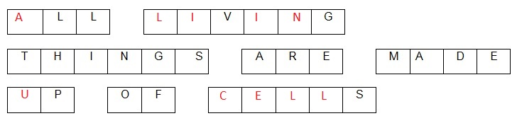The invention of the microscope allowed scientists to see that all living things are made up of cells.

6.2 Microscopes are used to study cells

Literacy support worksheet answers (pages 98–99)

Microscopes

1 Label the microscope below.

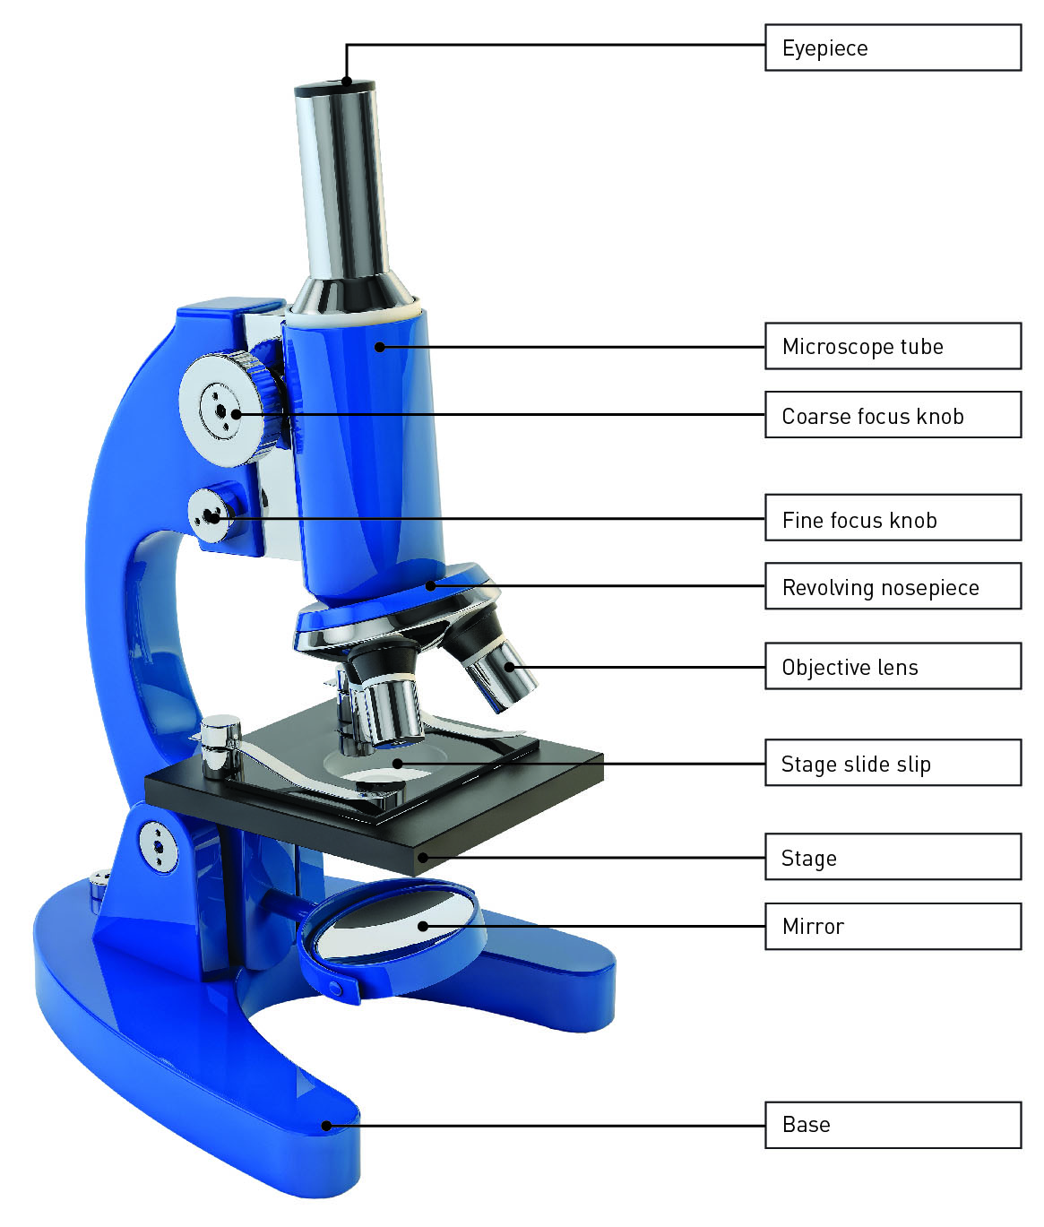

2 What are the three types of microscopes?

Electron microscope, stereo microscope and compound light microscope

3 Why are there three objective lenses on a compound light microscope?

To view specimens in different magnifications

4 Complete the following table to summarise the main differences between the three types of microscopes. Some of it has been completed for you.

|  |  |  |  |
| --- | --- | --- | --- |
|  | Compound light microscope | Stereo microscope | Scanning electron microscope |
| What is it used to observe? | Thin slices of specimens | Larger objects Whole insects | Tiny specimens |
| What is its magnification? | 1500x | 200x | 1–50 million times |
| Dimensions | 2D | 3D | 3D image |
| Can it see through an object or only the surface? | see through cells | Surface of a speciman | surface |
| Can it be used to see cells or whole organisms? | Cells and cell structures | whole | surfaces of cells |

Word discovery

5 Matching meaning

Draw a line to match the words on the left with the appropriate description sentence on the right.

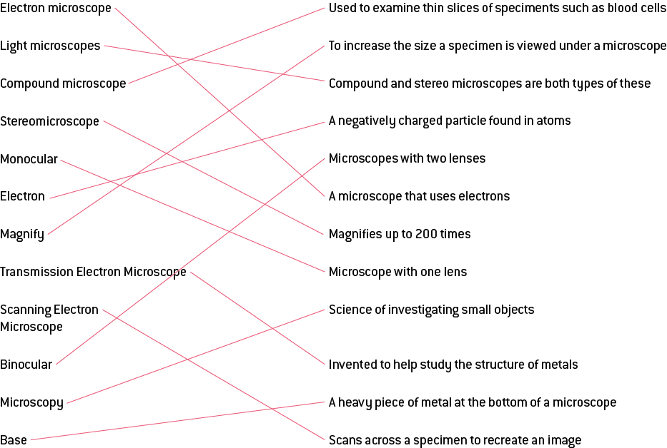

6.3 Plant and animal cells have organelles

Literacy support worksheet answers (pages 100–103)

Cell organelles

1 What are cellular organelles?

Organelles are mini-organs that have specialised function within the cell.

2 What is the function of the following cellular structures?

a Cell membrane:

Skin of cell; forms a barrier; allows nutrients in and wastes out

b Cytoplasm:

Jelly-like fluid inside the cell; contains nutrients and waste

c DNA:

Contains the instructions for every job the cells do

3 Label the organelles in the animal cell below and briefly state their function.

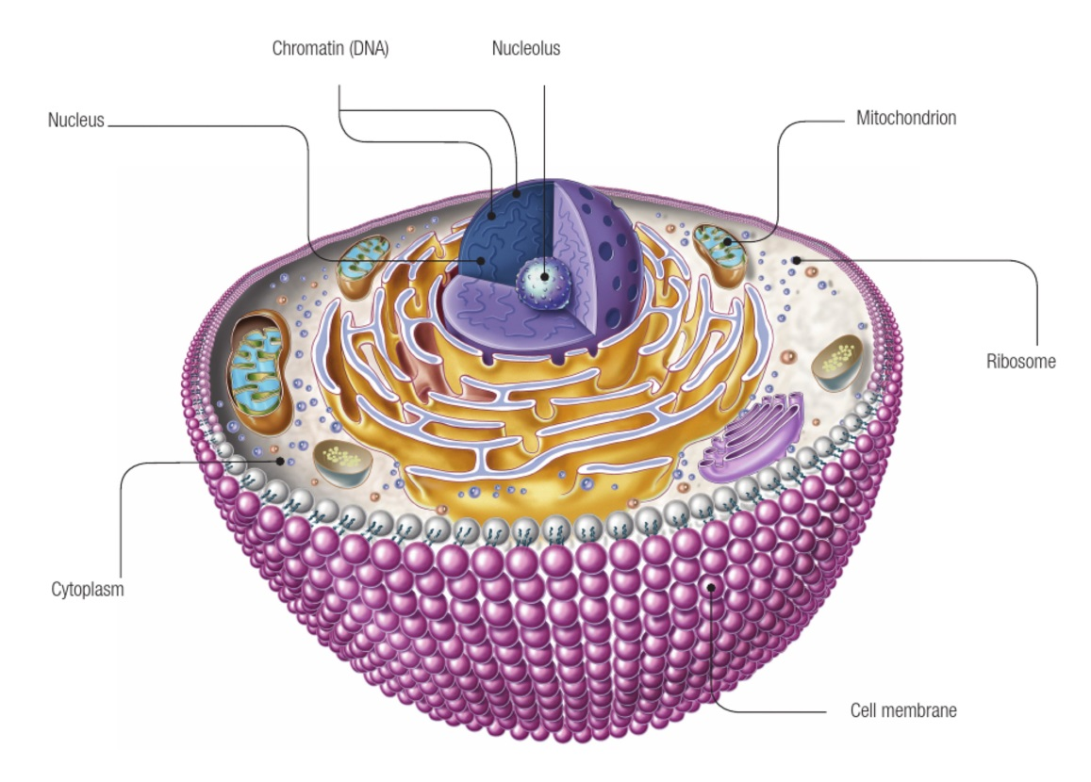

4 Label the organelles in the animal cell below and briefly state their function.

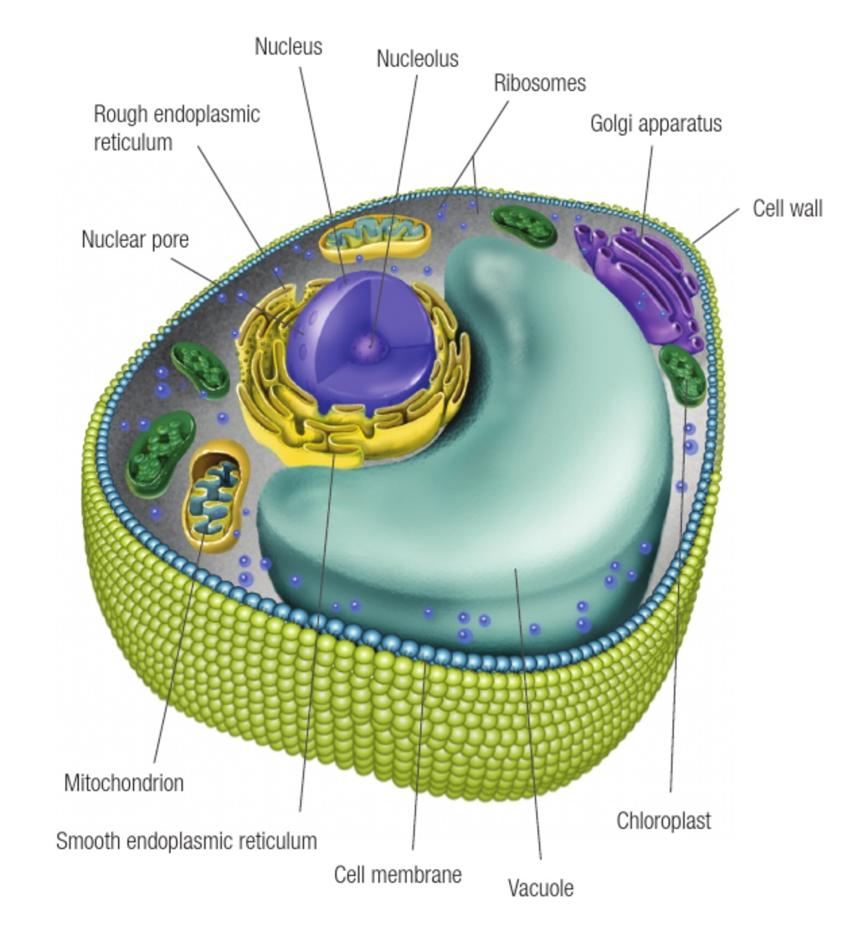

5 Complete the following Venn diagram by identifying which organelles belong to plants, animals or both.

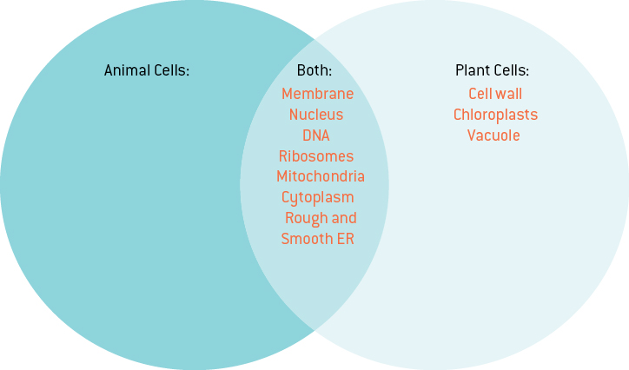

6 The chart to the right compares the size of different cells found in the human body. Measure each cell on page 103 from left to right and write your answer below – i.e., measure the length or diameter of the cell.

a Human egg cell:

100um

b White blood cell:

13–15um

c Red blood cell:

8um

d Cheek cell:

28-–30um

e Sperm cell:

30um

f Hair cross-section:

30um

Word detective

7 Draw and label

Draw and label a diagram of a mitochondrion. Including the following words: Inner membrane, matrix, cristae, DNA, outer membrane, enzyme complexes. If you need to, you can refer to page 102 of the student book to help you with your diagram.

Student diagrams will vary.

6.4 All organisms have cells that specialise

Literacy support worksheet answers (pages 104–105)

Specialised cells

1 What are the two main types of cells?

Prokaryotic and eukaryotic cells

2 Create a list of the characteristics of these two main groups of cells.

|  |  |
| --- | --- |
| **PROKARYOTIC** | **EUKARYOTIC** |
| Primitive | Complex |
| Kingdom Monera (bacteria) | Found in four kingdoms |
| No nucleus | Contain a nucleus |
| DNA floats free in cytoplasm | Contains most membrane bound organelles |
| unicellular | multicellular |

3 State which kingdom the following cells belong to. Use the pictures on pages 100–105 in the student book to help you.

|  |  |  |
| --- | --- | --- |
| Protist – amoeba page 105 |  | Plant – chloroplast picture on page 103 |
| Animal – sperm cell on page 100 |  | Protist – paramecium page 105 |
| Animal – intestinal cells on page 100 |  | Fungi – picture on page 104 |

Word detective

4 Mumbo jumbo

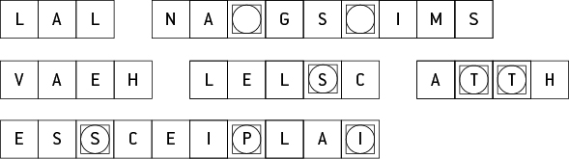

Message: All organisms have cells that specialise.

Secret word: Protists.

6.5 Bacteria are single-celled organisms

Literacy support worksheet answers (pages 106–107)

Bacteria – Kingdom Monera

1 How many cells make up a single bacterial organism?

One

2 What is a pathogen?

A microorganism that can potentially cause a disease

3 What is a host?

An organism on which another organism lives

4 What are three symptoms that you may look for if you were suffering from a disease?

Answers may vary, and include:

• Swelling

• Redness

• Pus

5 Name four types of harmful microbes and give two examples for each

|  |  |  |
| --- | --- | --- |
| Microbe | Example 1 | Example 2 |
| Fungi | Tinea (athletes foot) | Ear Infections |
| Protists | Malaria | Dysentery |
| Bacteria | Tuberculosis (TB), pneumonia | Legionnaires’ disease and cholera |
| Viruses | Common cold, flu | Measles and herpes |

6 Why is it harder to fight viruses?

They cannot be controlled by antibiotics as they hide in cells.

7 Can we use antibiotics to kill viruses? Explain.

No, they only kill bacteria.

8 What is the process of cell division in bacteria called?

Binary fission

9 At what temperatures do bacteria grow?

Bacterial growth stops below 4ᵒc

Bacterial growth stops above 60ᵒc

10 The following graph show the number of bacterial cells present in a person during a one week period.

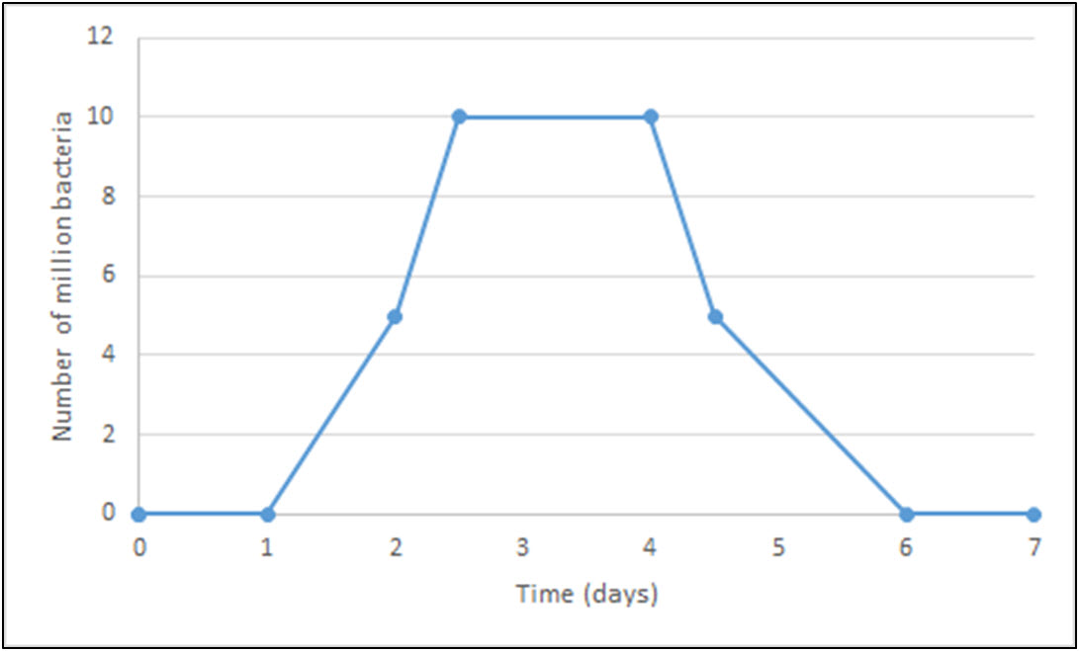

a When was the person producing the most bacteria?

Between day 1 and 2

b What could be the reason for this growth?

Binary fission, bacteria reproducing

c When did bacterial growth stop?

During day 2

d What could be the reason that the bacterial growth stopped?

Answers may vary and include – antibiotics; the person got well

Word detective

11 Boggle

The words listed below are incomplete. Using the clues provided, find the words in the puzzle to complete each word.

|  |  |
| --- | --- |
| WORD | CLUE |
| CELL | Each of these has a nucleus. |
| RIBOSOME | This is where protein is produced within a cell. |
| DNA | This carries genetic information in each person. |
| COLD | A common type of virus. |
| BODY | Harmful viruses can invade the human _ _ _ _. |
| BACTERIA | These have cell walls and contain DNA, but do not have a nucleus. |
| VIRUS | Scientists consider this to be a non-living pathogen. |
| FLORA | The microbes that live on our bodies are natural _ _ _ _ _. |
| SYMPTOMS | These occur when changes happen to a person as a consequence of disease. |
| VACUOLE | The space within the cytoplasm of a cell. |
| PATHOGEN | This is a microorganism that can potentially cause disease. |
| INFECTIOUS | _ _ _ _ _ _ _ _ _ _ diseases may be passed from one organism to another. |

6.6 Eukaryotic cells undergo mitosis

Literacy support worksheet answers (pages 108–109)

Mitosis

1 Name three functions your cells have to carry out for survival:

• Process substances

• Harness energy

• Reproduce

2 What does DNA do?

It holds the instructions for all cellular jobs.

3 What happens to the DNA before a cell splits to reproduce?

DNA must replicate (make a copy) of itself.

4 Label the process of mitosis on the diagram below.

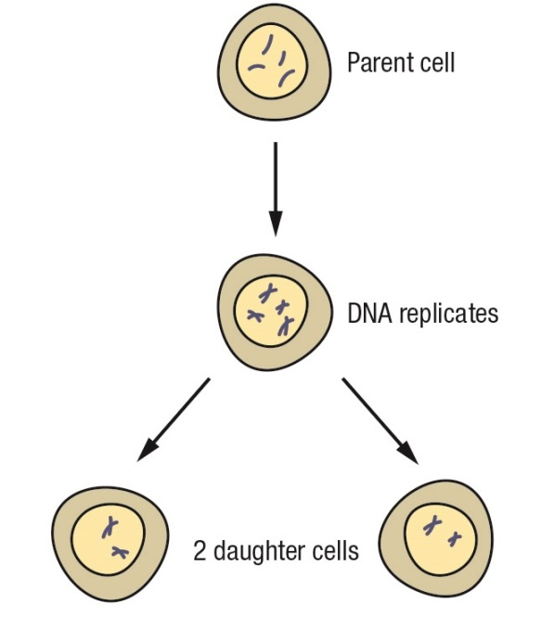

5 What is mitosis?

Mitosis is the process of cell division.

6 What is cancer?

Cancer is uncontrolled cell division.

7 Name three ways DNA can become damaged by mutagens:

• Radiation

• Viruses

• Chemicals

8 What is a carcinogen?

Carcinogen: when the damage to DNA causes Cancer. Cancer-causing chemicals can be carcinogens.

9 What is a tumour?

When cell division gets out of control, a lot of cells grow and form a mass known as a tumour.

10 What is a secondary cancer?

When cells break free from the tumour and spread throughout the body to destroy other organs

11 There are the two types of tumour, benign and malignant. Define each.

a Benign tumours:

Do not spread, not normally fatal

b Malignant tumours:

Spread throughout the body, fatal if spread is not stopped

Word detective

12 True or false

Read the statement and circle whether it is true or false.

a During mitosis cells split in half

T

b Mutagens are new cells

F

c Carcinogens are old cells

F

d Tumours grow when cells division gets out of control

T

e Tumours can split and spread causing secondary cancers

T

f Malignant tumours are not fatal

F

g The death of a cell is called apoptosis

T

h New cells created by mitosis are called son cells

F

6.7 Fungal cells can save lives

Literacy support worksheet answers (pages 110–111)

Using cells to save lives

1 Before antibiotics, what could have happened if you had a simple break in the skin?

It could have resulted in an infection. Before the 1900s there were no medications to kill these infections, so they could have been fatal.

2 What is a key property of mould that makes it essential to medicine?

It kills bacteria which is responsible for infection.

3 What discovery was made in 1928 by Alexander Fleming?

Fleming discovered that mould could prevent bacterial growth.

4 This discovery was an accident. Write a. b. or c. next to each sentence to place them in order.

c He concluded that the mould (penicillium) was stopping the bacteria from growing.

a Fleming was investigating bacterial growth and did not clean up properly before a holiday.

b Upon returning he discovered that bacteria could not grow where the mould had formed.

5 Where had the small spot of mould grown and what was happening around it?

The mould had grown in the centre of the plate. Around the mould was a clear circle where the bacteria could not grow.

6 How does this medicine stop bacterial growth/infection?

Penicillin stops the bacteria from repairing or making a new cell wall.

7 Who developed a method to isolate penicillin?

Howard Florey and Ernest Chain

8 A group of specialists got together to produce penicillin. Name the steps they took to do this.

a Grow the mould

b Extract the penicillin

c Purify it

d Trial its treatment on patients

9 Draw a line to match the dates on the left with the events on the ‘Penicillin Timeline’ on the right.

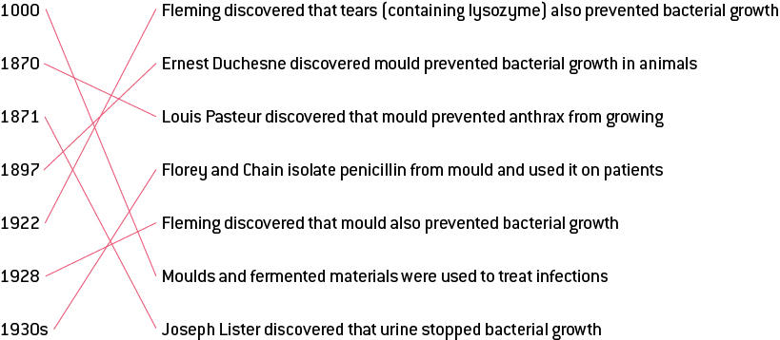

Word detective

10 Testing penicillin

Number each of the following sentences from 1 to 7, to complete the order of the experiment which tested penicillin in May 1940.

(7) Conclusion: Penicillin killed the streptococcal bacteria in the treated mice.

(2) Eight mice were infected with streptococcal bacteria.

(1) Prediction: Mould prevents bacterial growth**.**

(6) Mice treated with penicillin lived.

(3) Four of the mice were treated with penicillin.

(5) Mice who were not treated died.

(4) Four of the mice were NOT treated with penicillin.